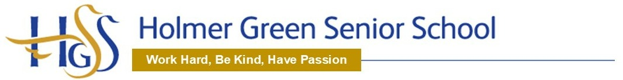
SUBJECT ACCESS REQUEST FORM

You should complete this form if you want us to supply you with a copy of any personal data we hold about you. You are currently entitled to receive this information under the Data Protection Act 1998 (DPA) and will continue to be under the EU General Data Protection Regulation (GDPR), which came into effect on 25 May 2018. We will also provide you with information about any processing of your personal data that is being carried out, the retention periods which apply to your personal data, and any rights to rectification, erasure, or restriction of processing that may exist.

We will endeavour to respond promptly and in any event within one month of the latest of the following:

• Our receipt of your written request; or

• Our receipt of any further information we may ask you to provide to enable us to comply with your request.

The information you supply in this form will only be used for the purposes of identifying the personal data you are requesting and responding to your request. You are not obliged to complete this form to make a request, but doing so will make it easier for us to process your request quickly.

SECTION 1: Details of the person requesting information

Full name:
Address:
Contact telephone number:
Email address:

SECTION 2: Are you the data subject?
Please tick the appropriate box and read the instructions which follow it.

YES: I am the data subject. I enclose proof of my identity (see below).
(please go to section 4)

NO: I am acting on behalf of the data subject. I have enclosed the data subject’s written authority and proof of the data subject’s identity and my own identity (see below).
(please go to section 3)

To ensure we are releasing data to the right person we require you to provide us with proof of your identity and of your address. Please supply us with a photocopy or scanned image (do not send the originals) of one of both of the following:
1) Proof of Identity
Passport, photo driving licence, national identity card, birth certificate.
2) Proof of Address
Utility bill, bank statement, credit card statement (no more than 3 months old); current driving licence; current TV licence; local authority tax bill, HMRC tax document (no more than 1 year old).

If we are not satisfied you are who you claim to be, we reserve the right to refuse to grant your request.

SECTION 3: Details of the data subject (if different from section 1)

Full name:
Address:
Contact telephone number:
Email address:

SECTION 4: What information are you seeking?
Please describe the information you are seeking. Please provide any relevant
details you think will help us to identify the information you require.

Please note that if the information you request reveals details directly or indirectly about another person we will have to seek the consent of that person before we can let you see that information. In certain circumstances, where disclosure would adversely affect the rights and freedoms of others, we may not be able to disclose the information to you, in which case you will be informed promptly and given full reasons for that decision.

While in most cases we will be happy to provide you with copies of the information you request, we nevertheless reserve the right, in accordance with section 8(2) of the DPA, not to provide you with copies of information requested if to do so would take “disproportionate effort”, or in accordance with Article 12 of the GDPR to charge a fee or refuse the request if it is considered to be “manifestly unfounded or excessive”. However, we will make every effort to provide you with a satisfactory form of access or summary of information if suitable.

SECTION 5: Information about the collection and processing of data
If you want information about any of the following, please tick the boxes:

▪ Why we are processing your personal data

▪ To whom your personal data are disclosed

▪ The source of your personal data

SECTION 7: Declaration

Please note that any attempt to mislead may result in prosecution.

I confirm that I have read and understood the terms of this subject access form and certify that the information given in this application is factually correct to the best of my knowledge. I understand that it is necessary for the school to confirm my / the data subject’s identity and it may be necessary to obtain more detailed information in order to locate the correct personal data.

Signed………………………………………… Date ……………………

Documents which must accompany this application:

• Evidence of your identity (see section 2)

• Evidence of the data subject’s identity (if different from above)

• Authorisation from the data subject to act on their behalf (if applicable)

Please return the completed form to:

Mrs Liz Plascott
Holmer Green Senior School
Parish Piece
Holmer Green
Bucks
HP15 6SP

Email: plascottl@holmer.org.uk

Correcting Information

If after you have received the information you have requested you believe that:

• the information is inaccurate or out of date; or

• we should no longer be holding that information; or

• we are using your information for a purpose of which you were unaware;

• we may have passed inaccurate information about you to someone else;

then you should notify our Data Protection Officer at once.

Mark Purdom

Email: mark@douc.tech

